Script On college dashboard.
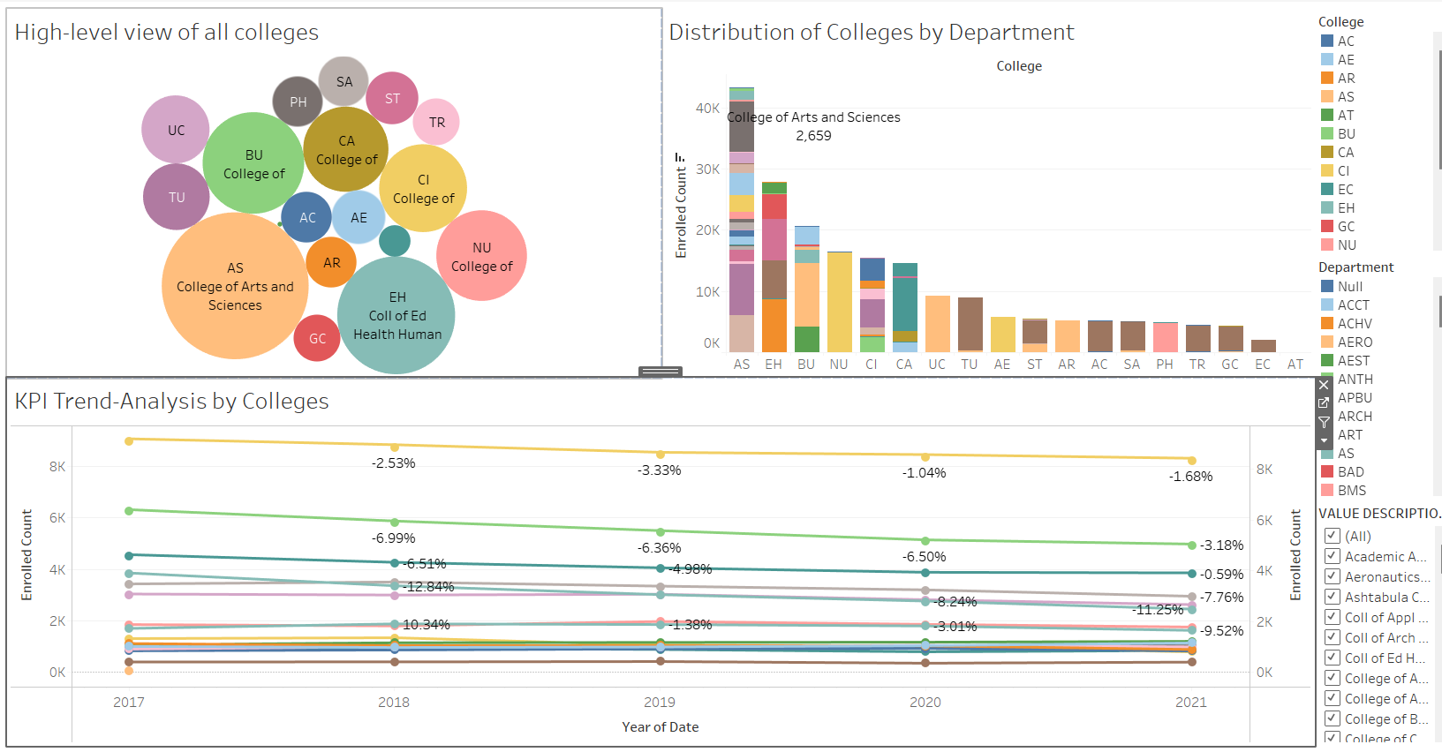

College Dashboard:
Here we have a College Dashboard where we can view the performance of colleges and attain such insights.
Secondly, will be 'All colleges-high level,' which will provide a detailed overview. In this graph, we are able to see a bubble chart, showing the enrolment number for each single College. Take for instance, the College of Arts and Sciences enrolment figure of 43,270 students which is highest and followed by the College of Education, Health and Human Services with 27,860students.
Furthermore, we will now look into 'The KPI By the Trend Colleges' section. Illustrating data through the multiple lines chart will enable us to analyze the admission pattern yearly according to each college. By looking at the fluctuations of totals or percentages of the institutions brings to us some important information about each one. Take for example the Tuscarawas Campus of the college was made of 10.34% enrolment growth in 2018.
Lastly in the 'Department-wise Distribution of College' section data here shows department wise distribution of the students where each college is shown below. Upshot of the stacked bar graph is the popularity index for the programs and departments. The College of Nursing recorded the highest enrolment count of 16,471 students in the whole College of Nursing department," as a case study.

